Create a New Key Pair

Create a new Key Pair

In this lab you create an SSH key pair that you will use to access your EC2 windows instance. Follow the steps below to create a unique key pair for you.

Navigate to the Amazon EC2 console . In the upper-right corner of the AWS Management Console, confirm you are in the desired AWS region.

Click on Key Pairs under the Network & Security section near the bottom of the left-hand menu.

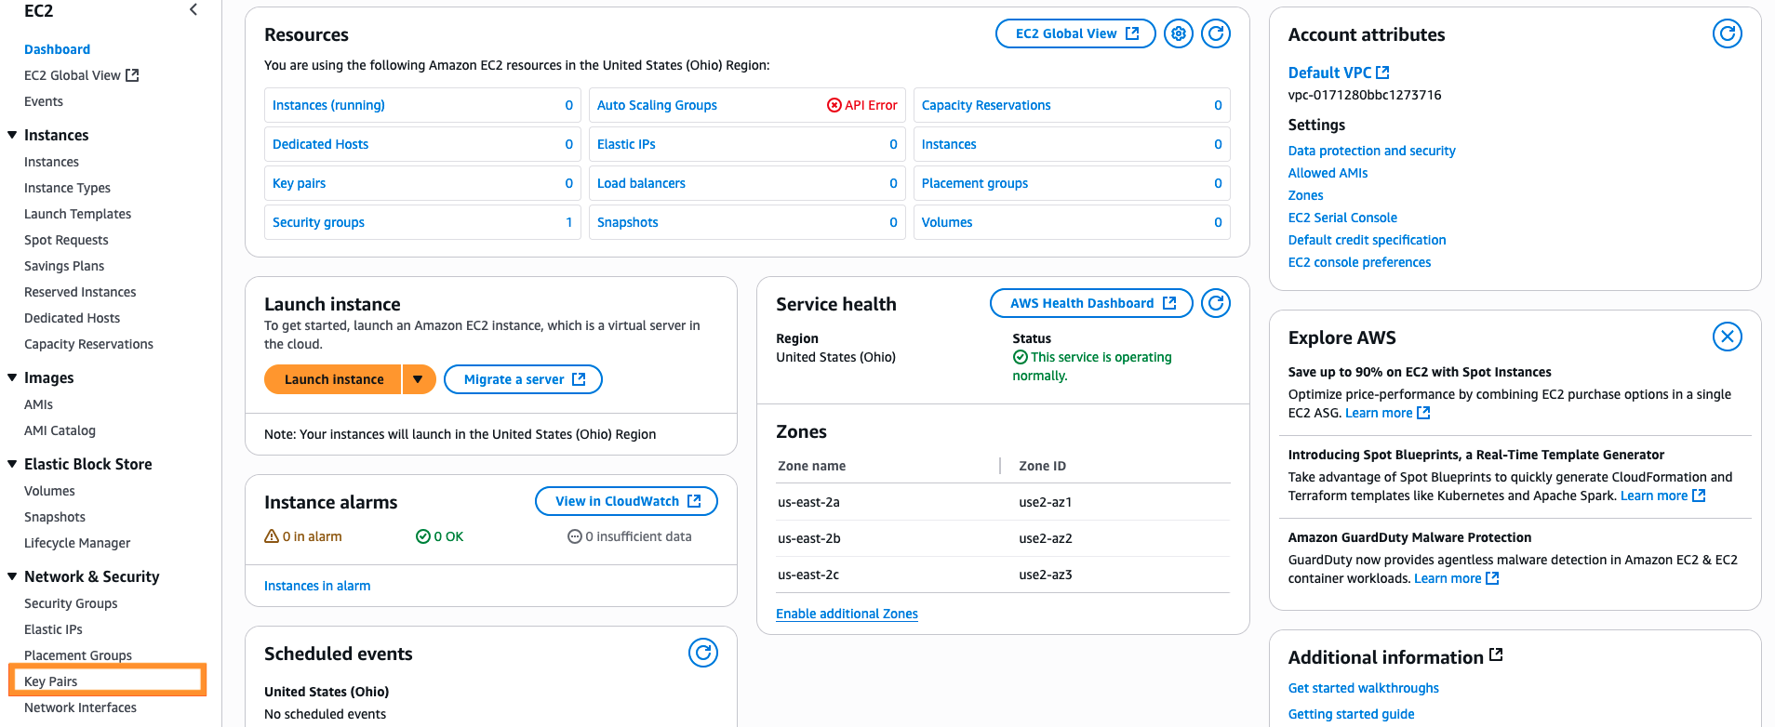

Click on Create key pair at the top right corner to create the new SSH Key Pair.

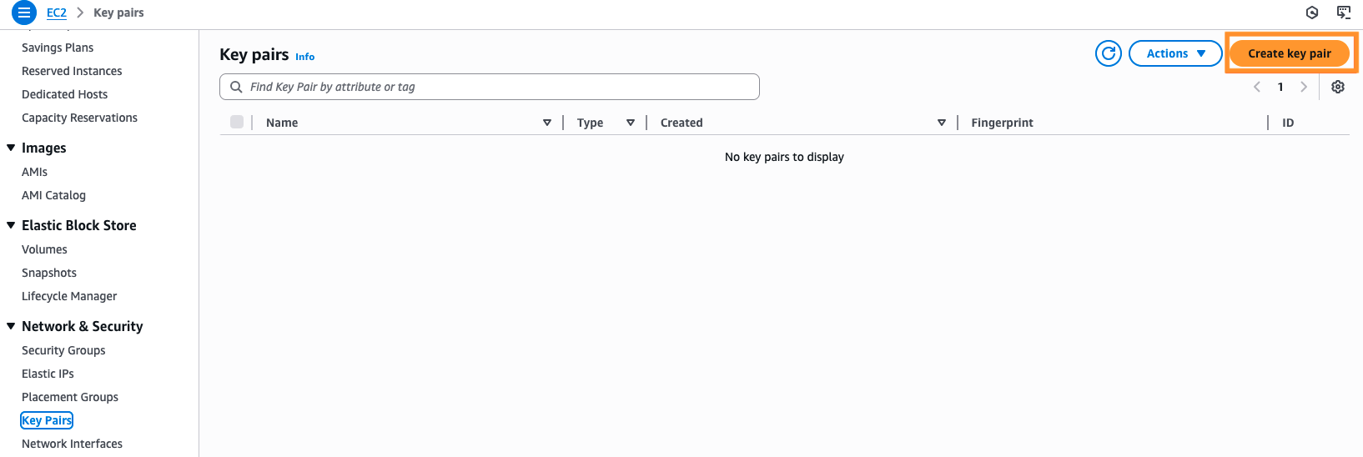

Enter [Your Name]-ImmersionDay-KeyPair into the Key Pair Name.

- Select .pem private key file format.

Then click on Create key pair.

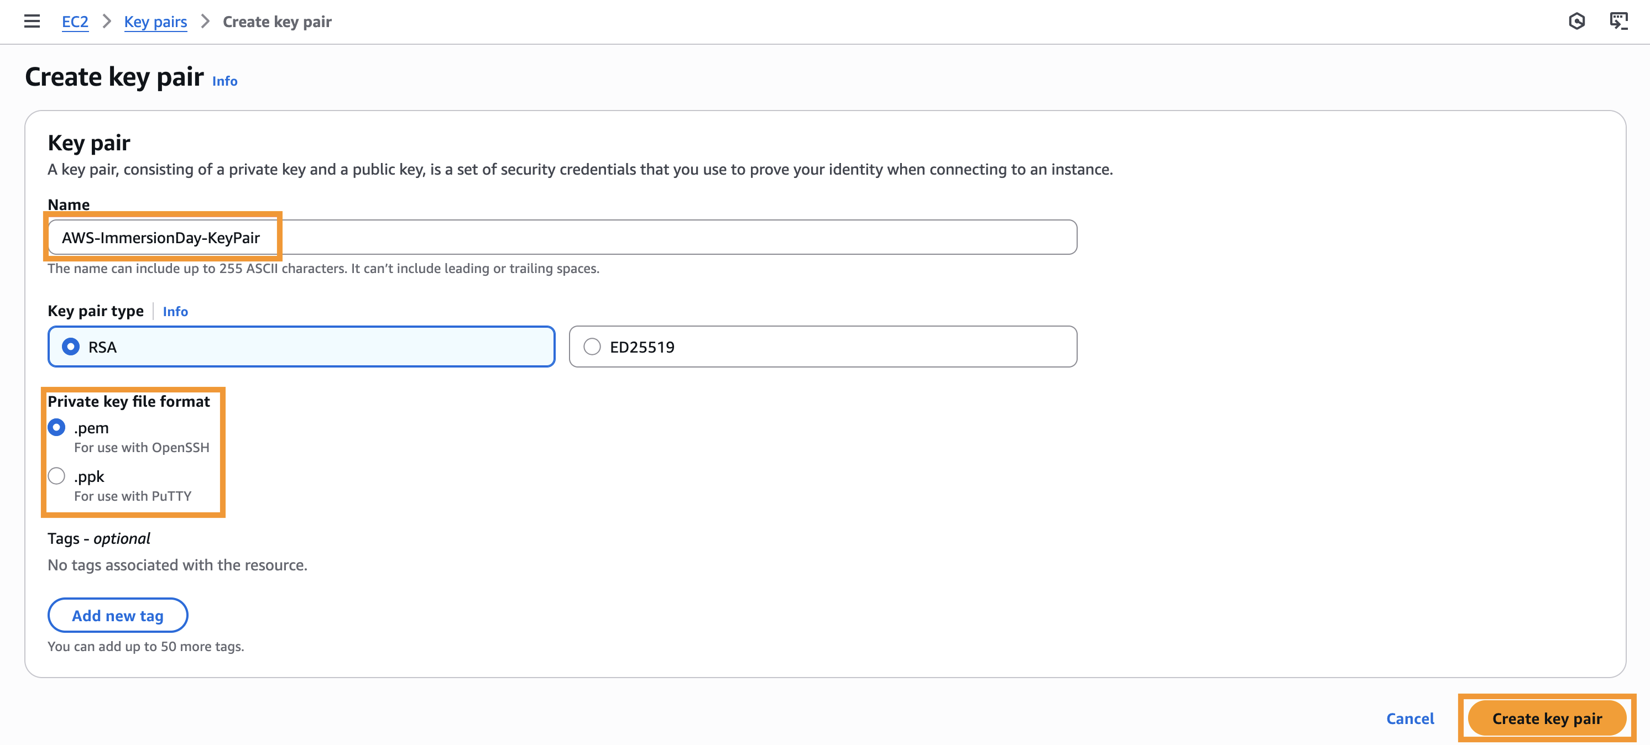

A file named [Your Name]-ImmersionDay.KeyPair.pem is downloaded to your local drive. Save the file to the default download location. Remember the full path to the key pair file you just downloaded.

You will use the key pair you just created to manage your EC2 instances for the rest of this lab.
You will use the key pair you just created to decrypt the administrator password for your EC2 instances in the rest of the lab.

